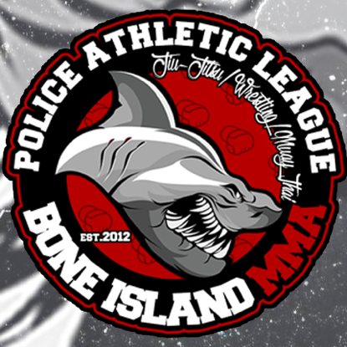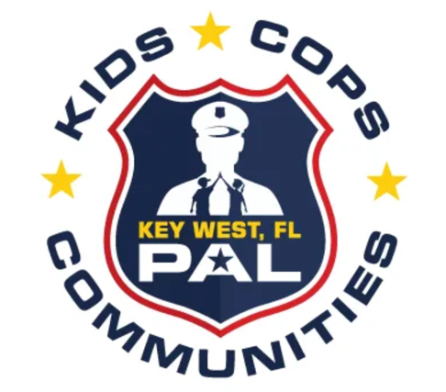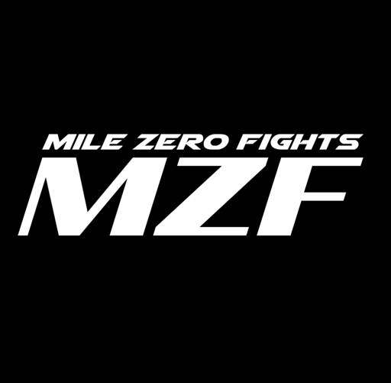

Aligning your business with Key West Police Athletic League and Mile Zero Fights will be benefiting the youth and is not only good for the community but is good for your business as well. Your association with us can help reach and impact your customer demographic and create brand experiences in a non-traditional way. Sponsorship packages include many tangible benefits to help your organization achieve marketing & communications objectives, underscore community commitment & social responsibility, receive positive media relations & press impressions and attract customers & generate leads.

ABOUT OUR NEXT EVENTS

Thursday, January 26, 2023 Weigh-In Event at Rock House live broadcasted on Roku with KeyWestPlus
Friday, January 27, 5:30 pm: Fight Day at Key West Police Athletic League

A list of events for the rest of the year will be emailed to you at the end of 2022!
Example of events for 2023: Athletic events, Festivals, City Fair & Music Concert, holiday parties for the community, fundraisers, and workshops!

OUR MISSION:
Key West PAL's mission is to provide local youth with focus and direction in order to help them become responsible citizens within our community. We provide quality youth sports, activities and educational programs designed to develop their skills, trust, discipline, self-esteem and respect. The goal is to create positive relationships between the youth, police and community.

Why Sponsor…

Community
GOOD FOR THE COMMUNITY | GOOD FOR YOUR BUSINESS
These events are outstanding opportunities to showcase all the great things KWPAL has to offer our neighbors, students, and our visitors. Take advantage of this opportunity! Join fellow community businesses and support our events in which KWPAL Bone Island BJJ students show their hard work and skills along with skilled professional fighters from out of town. Not to mention the scholarships provided to low-income families who depend on our programs for discipline, self-control, and defense training that provides productive and respectful future community members.

Publicity
OVER $20,000 IN ADVERTISING!
2023 has so much to offer you! Our events will be televised on Ruku’s KeyWestPlus channel so everyone
around the world can enjoy our programs! What does this mean for you? Your business will be featured on all of it! Don’t forget your logo will be on the ring girls, radio, banners, fliers, and the internet.

Additional publicity includes:
• Event banners and banner placement opportunities on site
• Inclusion in the schedule program
• Logo and link on the website with over 100,000 unique visitors
• Promotion on social media generating over 300,000 impressions
• And depending on the level, prominent booth space and/or opportunity to sample or do giveaways at one of the signature events

Title Sponsor ($ 12,000) – You want to make the biggest impact on the community?
Title sponsor branding, advertising and media package custom tailored to meet your vision for the ENTIRE YEAR 2023 of events is the best way for you! This includes Main event fights, Roku KeyWestPlus Channel, banners, media packages, radio airtime, Ring girls outfit logos, and so much more! We also deliver a banner to you to support our appreciation for your investment in our young athlete’s future in our programs. This donation makes a huge difference in our programs. Not to mention, your welcome to have a vendor booth supporting your business at our main events, festivals, and our county fair in 2023! Don’t forget to check your email and the website because you also get 2 tickets to attend our main events as a VIP !!! RSVP required.

Initiative Patron ($2500-11,000) – Patron sponsors will be featured prominently on advertising and media related to the Initiative along with the everything branded to the signature events. This highest level of commitment demonstrates to the community your organization’s dedication to making Mile Zero Fights/ KWPAL a better community service for all incomes to utilize.

Initiative Supporter ($300-$2500) – Initiative Supporters make a contribution to ensuring the success of the Mile Zero Fights/ KWPAL programs and events. Funds generated will be used toward fitness gear and supplies, advertising, signage, event expenses and overhead. Supporter’s generosity will be recognized in printed materials, social media, press events and more.

Community Sponsor ($50-$299) – Community Sponsor Supports contributions toward holiday camps and workshop scholarships. This directly impacts our students and low-Income families in their athletic adventure with KWPAL as well as parties and events for the kids. Supporter’s generosity will be recognized in printed and social media programs provides at two main events with your logo.

Want to be a Vendor at one or ALL of our main events?
SUBMIT A VENDOR APPLICATION
- Vendor space – ($50/$25 not-for-profit) 10x10 space. You provide tent, tables, etc. Limited electric. Preference given to hand-made items, Stock Island based.
- Food booth – ($75) 10x15 space. Tent or concession trailer. Generators preferred. We will limit the types of food and number of vendors to offer diversity.
- Activities for kids – (free) Groups or organizations providing free activities for kids will be given space at no charge.
- Musicians/Entertainers – (in-kind) Businesses or organizations may sponsor a band or entertainer (clown, juggler, face painter, etc.) to be a part of the event.
- Sponsor Application -- many custom opportunities to be a part of the events

Sponsorship Receipt

Name: enter

Organization: enter

Address: enter

Phone: enter

Email: enter

Website enter Facebook: enter

Logo : Email logo to: mzfmilezerofights@gmail.com
Sponsorship Level:
☐$12000 ☐$5000 ☐$2500 ☐$1000 ☐$500 ☐$250 ☐$100 ☐$50
☐ OTHER $____________ or Service ______________________________
☐Check # enter Amount___________ ☐Invoice ☐CC
Category
☐ Advertising/Promotion ☐ Art/Entertainment ☐ Automotive ☐ Business ☐ Charter Boats
☐ Commercial Fishing ☐ Community ☐ Friend of Mile Zero Fights/ KWPAL ☐ Lodging ☐ Marina
☐ Marine Services ☐ Restaurant/Bar ☐ Watersports   ☐ other enter

Size Ad – Social media and insert/program: Camera-ready ad is due Dec. 20th, 2022
☐ Full page (8 ½ x 11) included with $5000 sponsorship
☐ ½ page @ $2500 level included with sponsorship
☐ ¼ page @ $1000 level included with sponsorship
☐ Check if you want to purchase an ad without a sponsorship

☐ First 10 sponsors get FREE web ad with link on our webpage for December & January and a free page with logo, description, links & photos in the all new Guide to Stock Island mobile ap for three months.

Checks made payable to:
Key West Police Athletic League

Questions, please call:

Director:
Eddy Aguiar at 305-900-8114
mzfmilezerofights@gmail.com

Event Coordinator:
Crystal Smith at 305-407-0801

Thanks for your support! Florida not-for-profit Federal EIN is available
Upon request.

